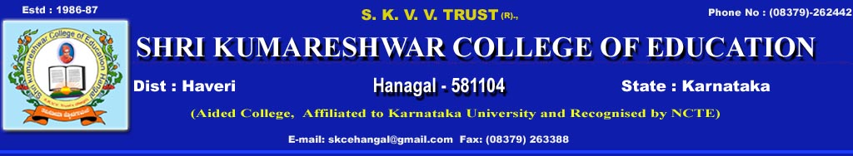
Date:13-04-2022. Location: Shri Kumareshwara College of Education Hangal.
Event:Janapada Ugadi Sambhrama.
Attendees: President of the function Principal Dr.Sadashivappa. N. sir
Shir Kumareshwara College of Education Hangal.
Chief guest of the function Dr. Nagraj Deshpande.
Guest of the function: Dr.Prakash Hullur sir and Dr. Vishwanath bondade sir.
The janapada Ugadi sambhrama function took place in Shri Kumareshwara College of Education Hangal is of grand success here the function was well started with the prayer song by savita and group followed by the welcome speech by Radha Hatti and entire programme was anchord by Ratnamma Gaji, janapada dance program by Poornima M.V and Kasturi teams was given.Continuing the program the skit was performed by Raju team expressed the patriotism then again the janapada dance was given by Pallavi and Jayshree team then our beloved Principal express his views on this cultural activities and said that India's rich culture and heritage was brought up and refreshed here without any caste discrimination. Further the chief guest of the function Dr.Nagraj Deshpande shared his experience and said that the cultures rituals are not written but practiced and transfer from generation to generation and thus in simple words we get great meanings of life at different stages. Then, the program was concluded by vote of thanks given by Shakuntala and the program was eShri Kumareshwara Vidyavardhak Trust (T)

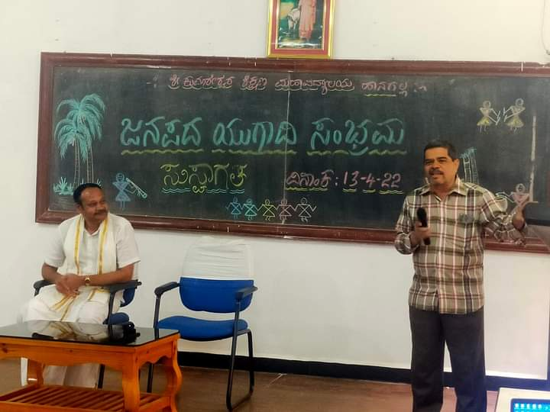
Dr.Nagraj Deshpande shared his experience and said that the cultures rituals are not written but practiced and transfer from generation to generation

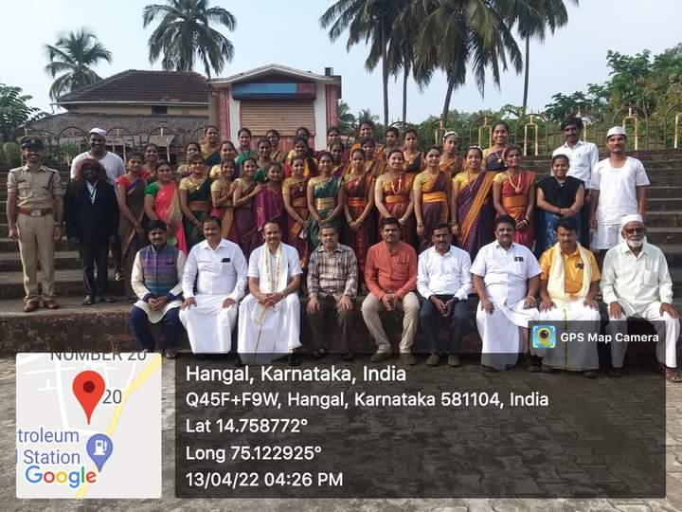
Group Photo About Ugadi sambram Progrem

